**GIT Notes:**

Add folder and Proj in Local Rep.

Step 1 :

Do the below,

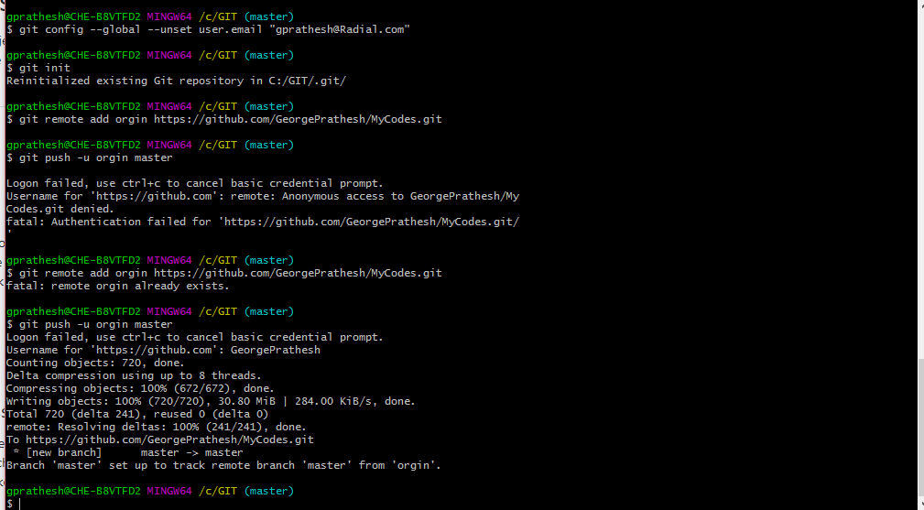

2)GIT Commit:

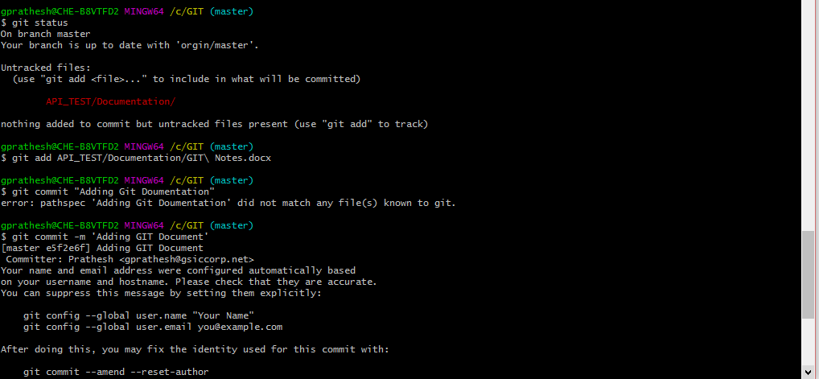

Step 3:

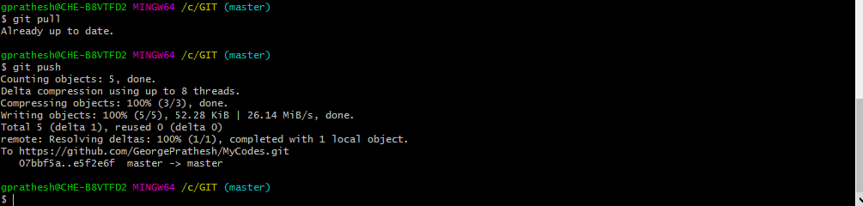

Step 4 :